1. SQL Exercise - Advanced concepts

Exercise 1: Ranking and Window Functions

Insert Sample Data:
CREATE DATABASE RankingFunctionsDB;
USE RankingFunctionsDB;
CREATE TABLE Product
(
ProductID INT PRIMARY KEY,
ProductName VARCHAR(50),
Category VARCHAR(50),
Price DECIMAL(10,2)
);
INSERT INTO Product VALUES
(101,'Laptop','Electronics',80000),
(102,'Mobile','Electronics',50000),
(103,'Tablet','Electronics',50000),
(104,'Headphones','Electronics',3000),

(105,'Shoes','Fashion',3500),
(106,'Jacket','Fashion',4500),
(107,'Watch','Fashion',4500),
(108,'T-Shirt','Fashion',1200),

(109,'Chair','Furniture',6000),
(110,'Table','Furniture',9000),
(111,'Sofa','Furniture',25000),
(112,'Cupboard','Furniture',25000);

View the Table:
SELECT * FROM Product;

Output:

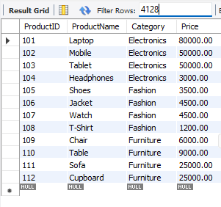
Use ROW_NUMBER():
SELECT
ProductID,
ProductName,
Category,
Price,
ROW_NUMBER() OVER
(
PARTITION BY Category
ORDER BY Price DESC
) AS Row_Num
FROM Product;
Output:
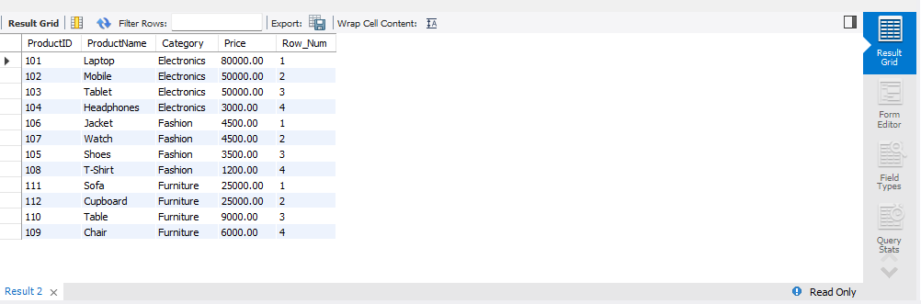
Use RANK():
SELECT
ProductID,
ProductName,
Category,
Price,
RANK() OVER
(
PARTITION BY Category
ORDER BY Price DESC
) AS Rank_Num
FROM Product;

Output:
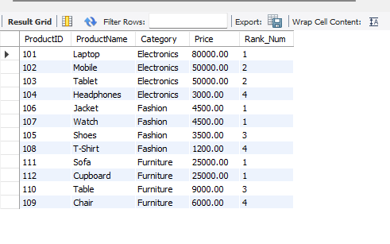
Use DENSE_RANK():
SELECT
ProductID,
ProductName,
Category,
Price,
DENSE_RANK() OVER
(
PARTITION BY Category
ORDER BY Price DESC
) AS Dense_Rank
FROM Product;

Output:
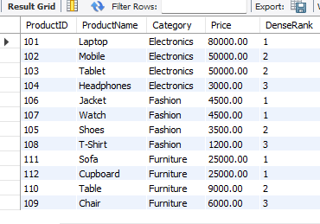
Compare All Three Ranking Functions:
SELECT
ProductID,
ProductName,
Category,
Price,
ROW_NUMBER() OVER
(
PARTITION BY Category
ORDER BY Price DESC
) AS Row_Number,
RANK() OVER
(
PARTITION BY Category
ORDER BY Price DESC
) AS Rank_Number,
DENSE_RANK() OVER
(
PARTITION BY Category
ORDER BY Price DESC
) AS Dense_Rank
FROM Product;
Output:
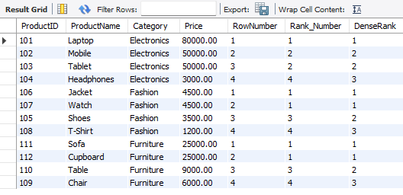
Find Top 3 Using RANK():
SELECT *
FROM (
SELECT
ProductID,
ProductName,
Category,
Price,
RANK() OVER
(
PARTITION BY Category
ORDER BY Price DESC
) AS Rank_Num
FROM Product
) AS RankedProducts
WHERE Rank_Num <= 3;

Output:
